**Sensor name:**flame sensor

**Flame sensor uses:**  
A flame-sensor is one kind of detector which is mainly designed for detecting as well as responding to the occurrence of a fire or flame.  
  
This sensor/detector can be built with an electronic circuit using a receiver like electromagnetic radiation. This sensor uses the infrared flame flash method, which allows the sensor to work through a coating of oil, dust, water vapor, otherwise ice.

### Module:

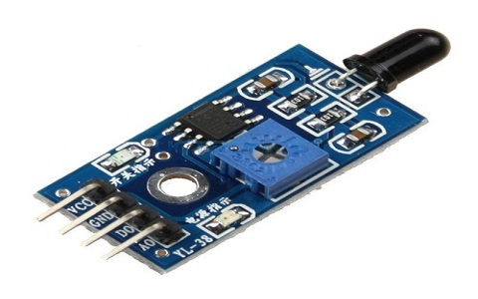

**Diagram:**

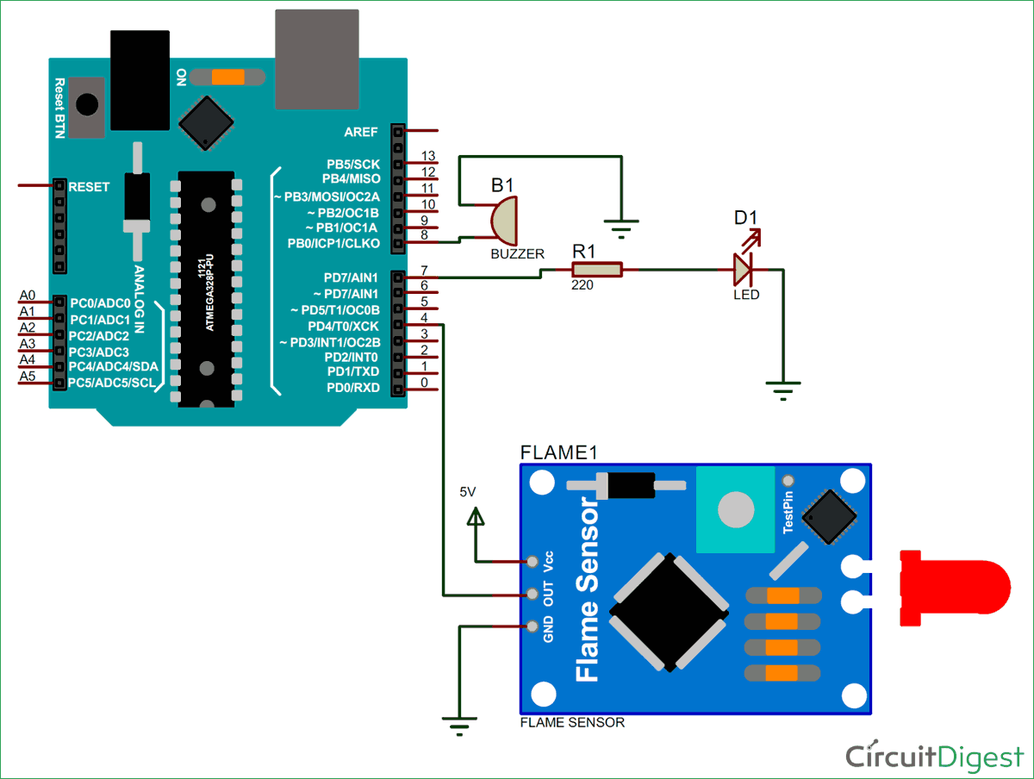

* Pin1 (VCC pin): Voltage supply rages from 3.3V to 5.3V
* Pin2 (GND): This is a ground pin
* Pin3 (AOUT): This is an analog output pin (MCU.IO)
* Pin4 (DOUT): This is a digital output pin (MCU.IO)

**FLAME SENSOR CODE:**

**#define BLYNK_PRINT Serial**

**#include <ESP8266WiFi.h>**

**#include <BlynkSimpleEsp8266.h>**

**// You should get Auth Token in the Blynk App.**

**// Go to the Project Settings (nut icon).**

**char auth[] = "uvklHbfF0xrq2Z62jJZMZcHKcDrfEh--";**

**// Your WiFi credentials.**

**// Set password to "" for open networks.**

**char ssid[] = "MRazine";**

**char pass[] = "Razine22@we.com";**

**#define ledFlame D0**

**#define inputFlame D1**

**#define ledSmoke D5**

**#define inputSmoke D6**

**void setup()**

**{**

**// Debug console**

**Serial.begin(115200);**

**pinMode(ledFlame, OUTPUT); // declare LED as output**

**pinMode(inputFlame, INPUT); // declare sensor as input**

**pinMode(ledSmoke, OUTPUT); // declare LED as output**

**pinMode(inputSmoke, INPUT); // declare sensor as input**

**Blynk.begin(auth, ssid, pass);**

**// You can also specify server:**

**// Blynk.begin(auth, ssid, pass, "blynk-cloud.com", 80);**

**// Blynk.begin(auth, ssid, pass, IPAddress(192,168,1,100), 8080);**

**}**

**void loop()**

**{**

**// int Flame = 0; // variable for reading the pin status**

**// Flame = digitalRead(inputFlame); // read input value**

**int Smoke = 0; // variable for reading the pin status**

**Smoke = digitalRead(inputSmoke); // read input value**

**if (Flame == 0) { // check if the input is HIGH**

**Serial.println("Fire\n");**

**Blynk.notify("Fire Detected!!!");**

**digitalWrite(ledFlame, HIGH); // turn LED ON**

**delay(550);**

**}else {**

**Serial.println("NormalState");**

**digitalWrite(ledFlame, LOW);**

**}**

**if (Smoke == 0 ){**

**Serial.println("Smoke\n");**

**Blynk.notify("Smoke Detected!!!");**

**digitalWrite(ledSmoke, HIGH); // turn LED ON**

**delay(1000);**

**}**

**else {**

**Serial.println("NormalState");**

**delay(250);**

**digitalWrite(ledSmoke, LOW);**

**}**

**Blynk.run();**

**}**

**//**